**MSF 6920 Practice Final Exam**

**Programming Exercises:** Read through both programming exercises carefully. We will be giving partial credit, so make sure you prioritize your time to get as many of the requirements completed as possible. **Hint:** do user validation and formatting after you get the code to run.

**Exercise 1**

***Hint Examples: Class 8 Ex 2, Class 9 Demo 1

Create program that calls the function avg_value(sqft,bath,year,num) from the python file “finalcode.py” which is available on canvas.

The function avg_value will return the average value of the homes in real estate portfolio.

Write the main function to call avg_value function and execute to the following requirements:

a) Get user input on the number of properties

b) Based on that input, the user will enter the square footage, # bathrooms, and year built for each property.

c) Call the function, which returns average output.

d) Print the average value to the format of the sample output:

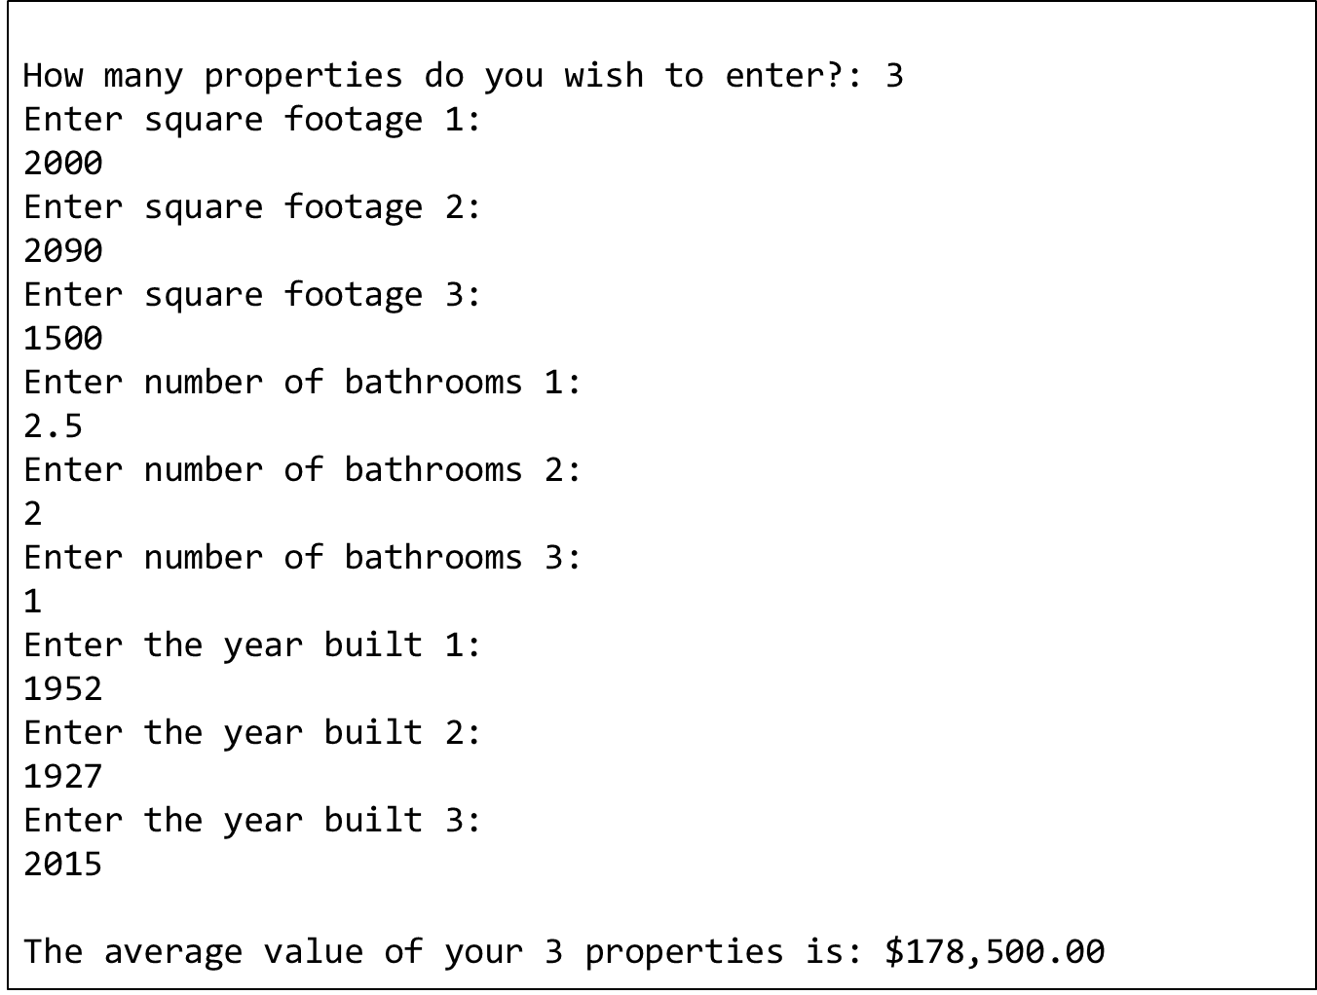.

**Exercise 2 Hint Problem – Class 7 Ex 1, Class 12 Ex 4, Class 3 Ex 5.2**

Write a program that will return the value in today’s dollars of a dollar amount from a given year. The program must read date from inflation.csv and meet the following requirements:

a) User is prompted to enter a beginning year and dollar amount.

b) Create user validation such that they cannot enter a year before 1950 or after 2024, nor enter a negative number for the dollar amount.

c) Calculate the average inflation from the year the user entered to 2024. The inflation rates used in the average must come from the inflation.csv file.

d) Use the average inflation rate to calculate the value of X dollars in year YYYY in today’s (2024) dollars. non-code example: todays$ = past$/(1+inflation)^timeframe

e) Return the value in today’s dollars, formatted to the sample output.

f) Return a data visualization of the inflation rate per the sample output.

g) Ask the user if they wish to enter another value and then run program again they choose.

f) Format values appropriately

Enter the year from 1950 to 2024: 1988

Enter the amount in today's US Dollars: 10000

The value of $10,000.00 today was worth $3,714.43 in 1988.

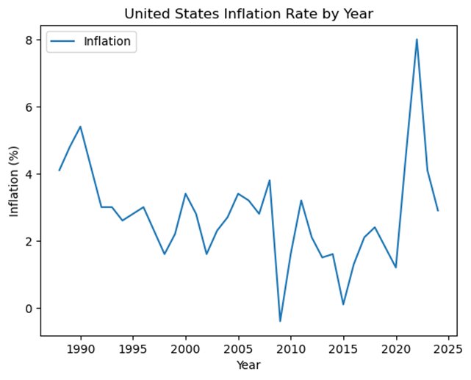

Do you want to enter another year? y for yes: n